Hi Najae

Good day, I’m a dog person which is interested in your post,

Actually, there are many random variables in dog ownership needs to be considering by religion, country or region.

There are some research data. Have a nice day.

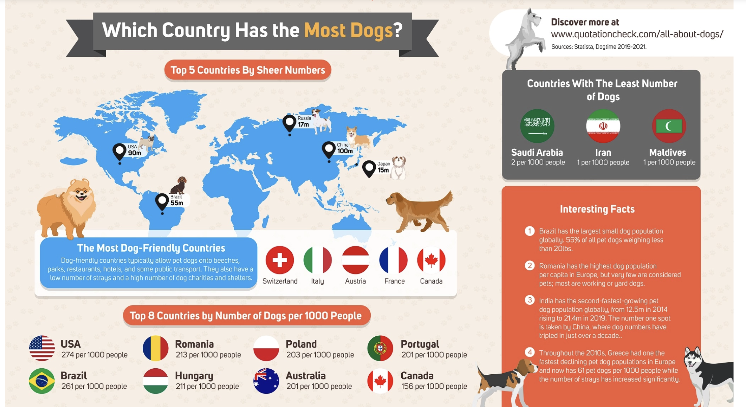

Reference:

Statista Research Department (2016). Pet ownership worldwide in 2016, by country. Statista. https://www.statista.com/statistics/961098/worldwide-pet-ownership-by-type-by-country/